**Scripts-side Documentation**

1. **Avatar Scripts**
   1. AvatarBackend
   2. AvatarManager
   3. Pedestrian
2. **Backend Scripts**
   1. DataParse
   2. RoadsBackend
   3. UserDataBackend
   4. GarbageCollector
3. **Camera Scripts**
   1. FirstPersonMainCamera
4. **GUI Scripts**
   1. RightOfWayUI
   2. StreetFurnitureUI
      1. EditObjectUI integration
         1. MovementUI
         2. RotationUI
         3. ScalingUI
      2. PreviewManager
         1. RotateObject
   3. UIControl
   4. GhostSelectedObjects
   5. FileBrowserUI and ScreenshotUI
5. **Login Scripts**
   1. MainMenu
   2. Tutorial
   3. FadeScript
6. **Right-Of-Way Scripts**
   1. CreateAllRoads
   2. RoadSegmentMain
   3. InstantiateRoadElements
   4. InstantiateIntersections
   5. Others
      1. RoadElementsArray
7. **Urban Design Object Handler**
   1. ObjectLibrary
   2. Group
   3. SubGroup
   4. GenericObject
8. **C# Scripts for Compiling**
   1. PieMenu.cs
   2. PieMenuManager.cs
9. **Image Effects (Pro Only)**

In the Scripts-side documentation, we hope to describe how scripts are related in an organized fashion so that future developer can have a better sense when error occurs. In this document, we hope to explain some of the reasons of why we created the respective code and thus future developers can change and add scripts in a more effective manner. Inevitably, this document is going to be tightly intertwined with the Hierarchy documentation. It is advised to read the Hierarchy documentation before reading the Scripts-side documentation.

The items listed above is an overview of the scripts we have worked on; however, we will proceed the documentation in a chronological order of how users are going to interact with IRUS. Only the highlighted items are mentioned in the Scripts-side documentation.

**Overview**

Scripts in Unity can manipulate most of the variables, but some of them, like AnimationEvents, GUI Skin, tagging, Colliders, are best to be done in the **Inspector** and **Hierarchy View**. It is easier to adjust and compare. In the Editor mode of Unity (i.e. after you click the “Play” button in Unity), you can adjust different variables in runtime through the **Inspector** to give immediate feedback (useful when positioning different GUIs). The variables in the inspector are all public variables, which can be set in the script.

In the Spring 2013 work term, we have implemented the save and load functionality on the Right Of Way Editor and the Urban Design Editor. There is two sets of data could be loaded: the **Preset data** (under */Assets/Resources/Databases/Ward_7*) and the User data. The Preset data refers to the existing condition of the city; and the User data is the changes modified by the user. In addition, there is a **Temporary Data** folder under the Resources folder. The temporary data folder will be cleared every time the user login, it keeps track of the changes made by the user in the current session. It is used in the undo function of the editor. Under the User Data folder, there is also the *LastLoginRegister.txt* file that is registered every time the user enters a game scene (except for the MainMenu scene and the Tutorial scene).

The underlined bullet point listed on the first page is the corresponded to the Files under the Assets Folder *(/Assets/…*). Most of the IRUS scripts are placed under the IRUS Script Folder *(/Assets/IRUS Scripts/…*); however, there are also different scripts under the Standard Assets (*/Assets/Standard Assets/…*) and the Purchased Assets (*/Assets/Purchased Assets/…*). The scripts under the Standard Assets and Purchased Assets folders are used in IRUS but it usually means that they are imported from somewhere else. For example, the Image Effects Scripts under Purchased Assets (*/Assets/Purchased Assets/Image Effects (Pro Only)*) are imported from Unity Pro itself. The Image Effects Scripts contains a variety of scripts to enhance different effects on the camera. They are written by other developers and are only available with Unity Pro. In case IRUS developers may want to use them in the future, here is the reference link: <http://docs.unity3d.com/Documentation/Components/comp-ImageEffects.html>

For the most part, developers can choose any names for the folders in IRUS project but Unity reserves some names to indicate that the contents have a special purpose. Some of these folders have an effect on the order of script compilation. The Script Compilation Order is documented in Unity: <http://docs.unity3d.com/Documentation/Manual/ScriptCompileOrderFolders.html>

As mentioned in the Documentation Preface, most of the IRUS scripts (this term) are written in UnityScript (a crippled form of javascript). We will start the Scripts-side documentation from the Right Of Way Editor as in the Hierarchy Documentation; however, unlike the Hierarchy Documentation, we will talk about how the Road Information is presented in the Right Of Way Editor from frontend to backend in a top-down fashion.

Before start reading the documentation, please read the section **Execution Order of Events** in the **Documentation Preface**. It explains some built-in functions used in each script.

The first script we are going to talk about is the RightOfWayUI script. Then, we will proceed to talk about how each road elements is drawn/instantiated in the InstantiateRoadElements scripts and how road information is being populated to the InstantiateRoadElements from the database. Eventually, we will talk about how the backend is structured to assist the frontend. We will then move to another UI and explained it in a top-down fashion again. Hopefully by looking from different angles, developers may have a better sense of the entire structure of the IRUS project.

**RightOfWayUI.js (***/Assets/IRUS Scripts/GUI Scripts/***)**

The RightOfWay Editor allows user to make adjustment to the road elements (e.g. sidewalks and traffic lane). In general, there are 2 components making up the entire roads network: the **Road Segments** and the **Intersections**. There are also **Shapes**, which are transitional shapes between road segments of different widths. However, in the current IRUS version, we eliminated the Shapes along King Street by making the right of way the same width in the CityEngine. Nevertheless, there will still be Shapes in the World and they are under the **Hierarchy** (/Uptown Waterloo/OtherRoadElements).

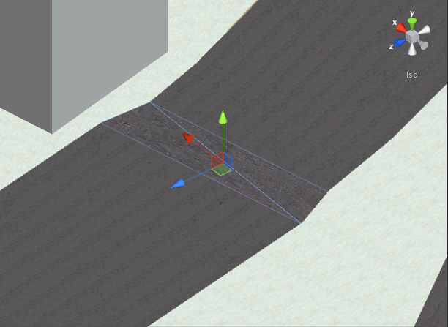

Therefore, when user makes changes to the Right Of Way, we have to update both the changed road segments and the intersections attached to them.

Here, we will explain a little bit more about the imported models from CityEngine. CityEngine is a program that takes Geospatial Data and converts it to a 3D city environment. In real world, it is rare that the entire road has the same width; even within the same street block, there could still be different widths on different parts. When CityEngine encounters different widths on the same road, it breaks the entire road into different segments. Thus, when those models are imported to Unity, the different segments are imported as well.

However, when user makes changes to a road segment, it usually implies all the road segments on the same block. The RightOfWay Editor takes care of this problem by looking up the reference databases provided by the CreateAllRoads.js script. The **CreateAllRoads.js** script extracts the reference databases from (*/Assets/Resources/Databases/Ward_[number]/*.csv*) when the road segments are first initialized on the start of the level. In the database (e.g. Ward_7_RoadsInfo.csv), there are 3 fields**: FROM_STREE** (From Street), **TO_STREET** (To Street) and **STREET_NAM** (Street Name). For road segments that are in the same block, the three fields above must be the same.

Most of the functions in RightOfWayUI.js are used within itself. Broadly speaking, there are 2 types of functions: the **UI-related** functions and the **Backend-related** functions.

The **UI-related** functions refer to the helper functions to draw the 2D GUI elements on the screen (i.e. the RightOfWay Editor itself) and the **Backend-related** functions are those that track and verify the changes then update the backend or throw errors to the users correspondingly.

Basically, there are 3 stages of using the RightOfWay Editor:

1. To select which road segments to edit
2. If the selected road segment is not initialized, then the cross-section area is not drawn until the user applies changes for the lane creator.
3. After the user has made all kinds of changes, either saves the road settings or reverts it back to the previous state.

The first 2 stages are obviously coded in the **Update** function. A Physics.Raycast function is used to detect which road segment is selected when the “*menuEnabled*” is false. Once a valid road segment is selected, the RightOfWayUI.js then takes a copy of the variables of the road segment (from the **InstantiateRoadElements.js** of the road segment). These variables include: unityName, roadWidth, roadName, roadType, isOneWay, leftWidths, leftTypes, medianWidth, medianType, rightWidths, rightTypes, numSegmentsLeft and numSegmentsRight.

Next, if the selected road segment is already initialized, then the “*spaceConfigured*” (to allow the cross-section being drawn) is set to true. However, if the selected road segment is not initialized, then the user needs to “**Apply Changes**” for the **Lane Creator**.

The last stage will be described in more details in this section. Basically, all the 2D GUI elements the user can interact with are coded in the **OnGUI** function.

The **OnGUI** function is usually called multiple times per frame. It is called for rendering and handling GUI events. It used the UI-related functions directly or indirectly through the lifetime of the RightOfWay Editor. In general, there are 2 classes that are used for OnGUI function: the **GUI** class and the **GUILayout** class.

GUI and GUILayout basically do the same thing (to draw 2D elements on the screen), but **GUILayout** class organizes the positions of the elements automatically while a specified position and size have to be determined for the **GUI** class. In addition, the GUILayout typically consumes 2 to 4 times more CPU usage than GUI class. This can be verified using the **Profiler** (Unity Pro only).

For the RightOfWayUI.js, the GUILayout class is used in most of the code. However, future coops should try to migrate it back to GUI for efficiency. The blueprint of the RightOfWay user interface is provided below.

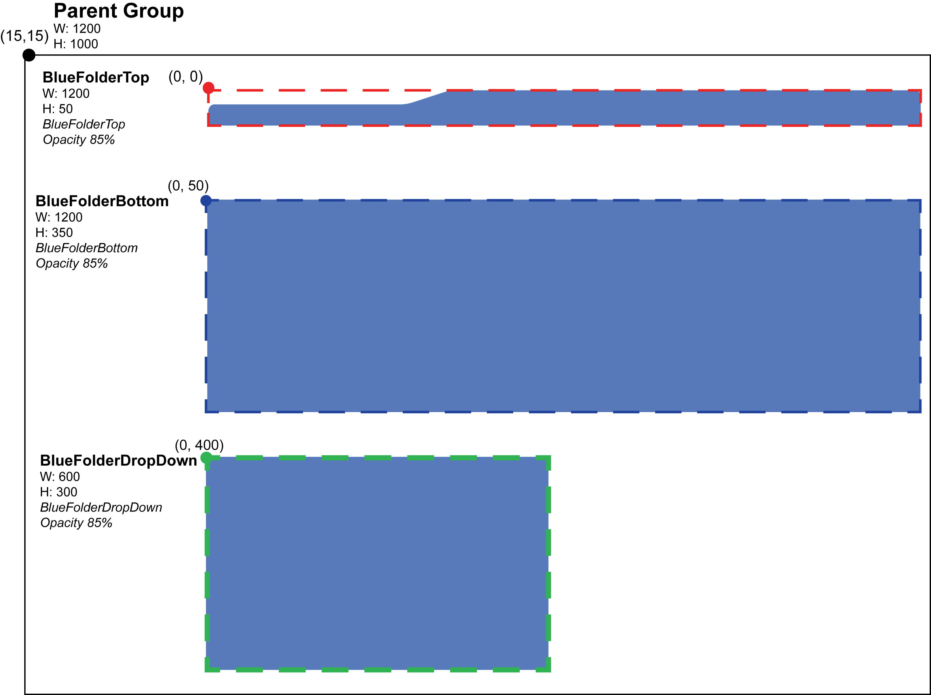

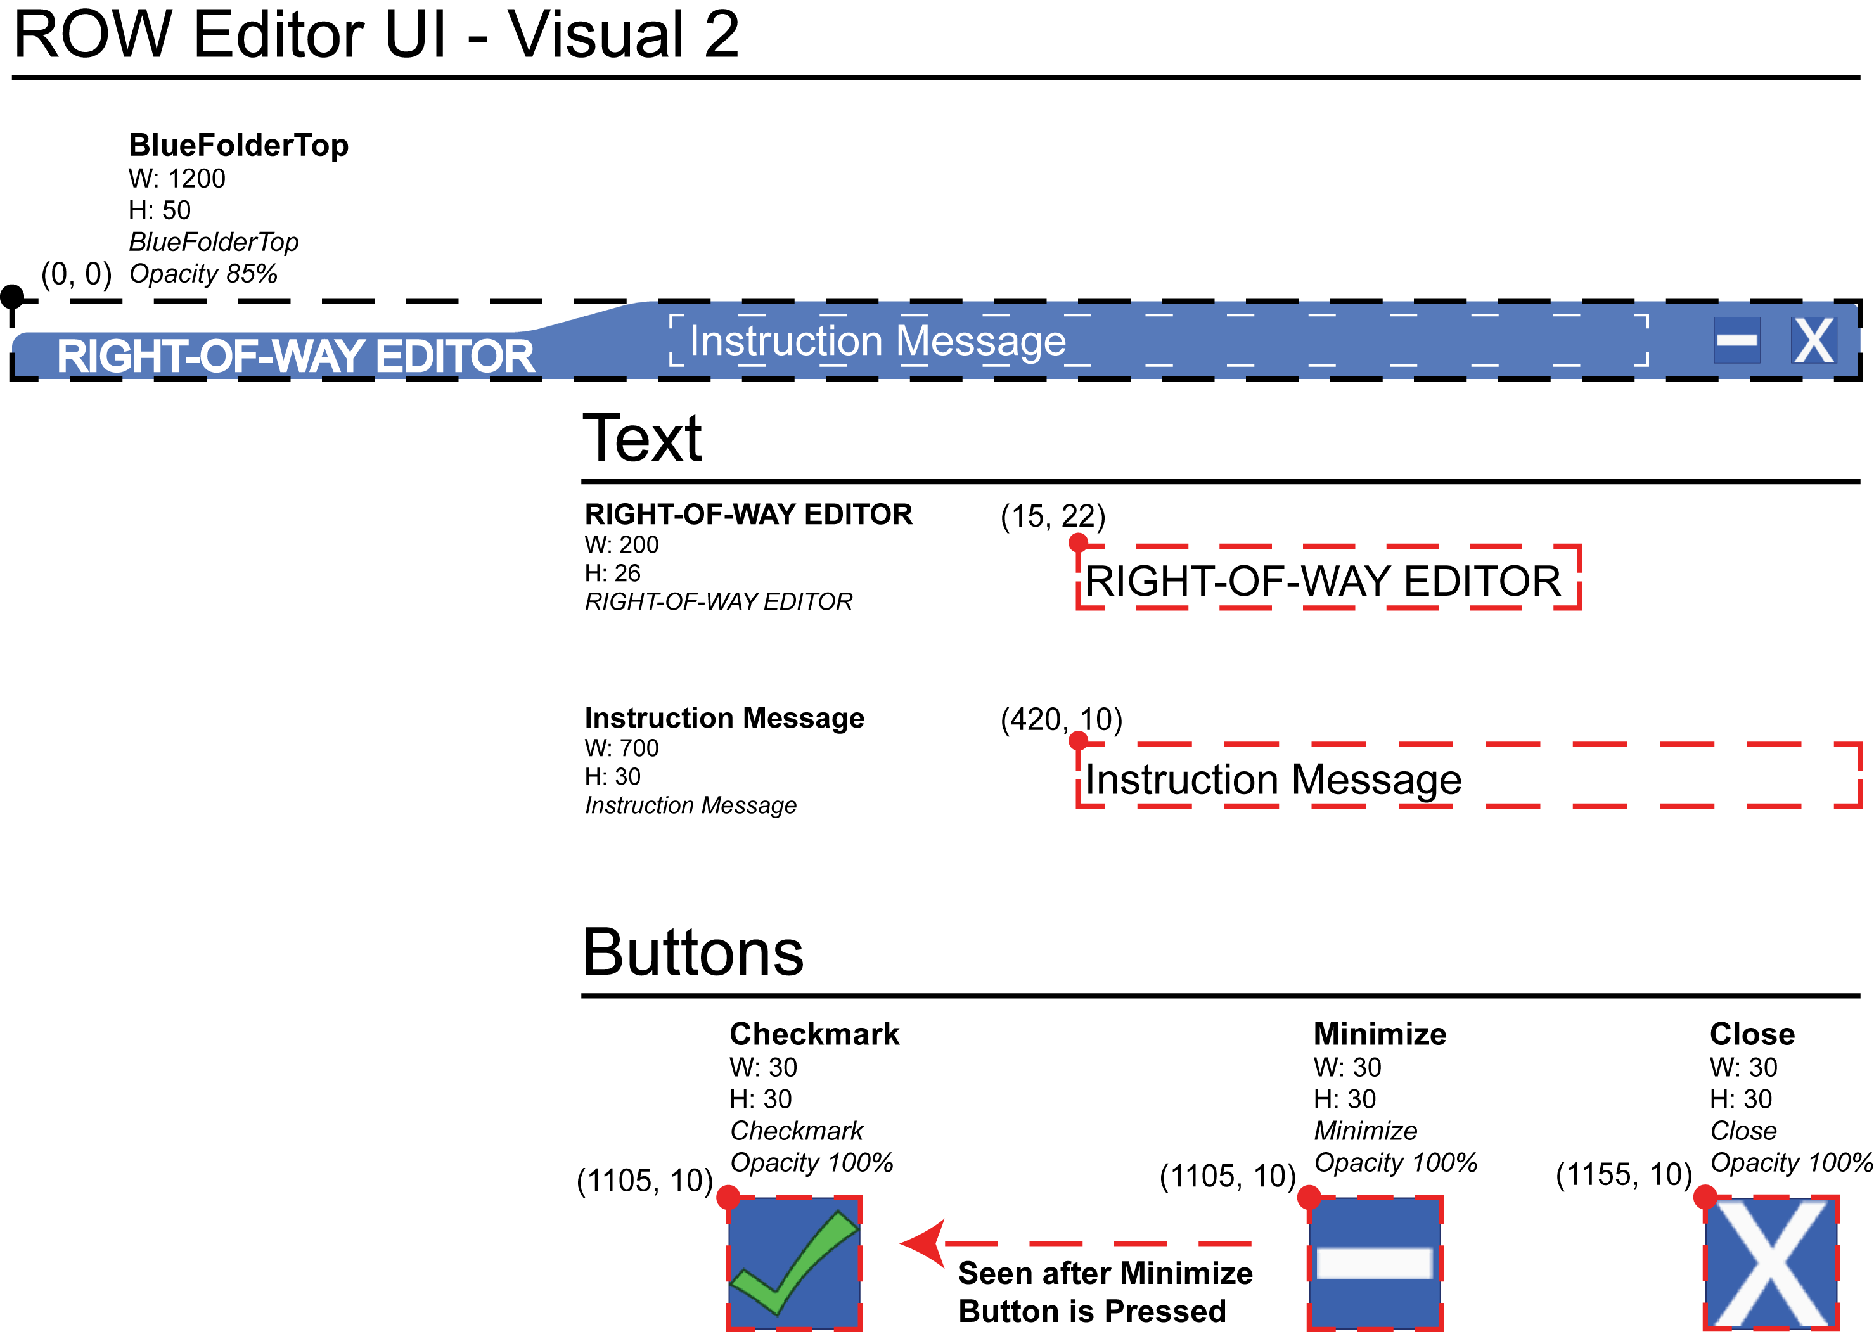

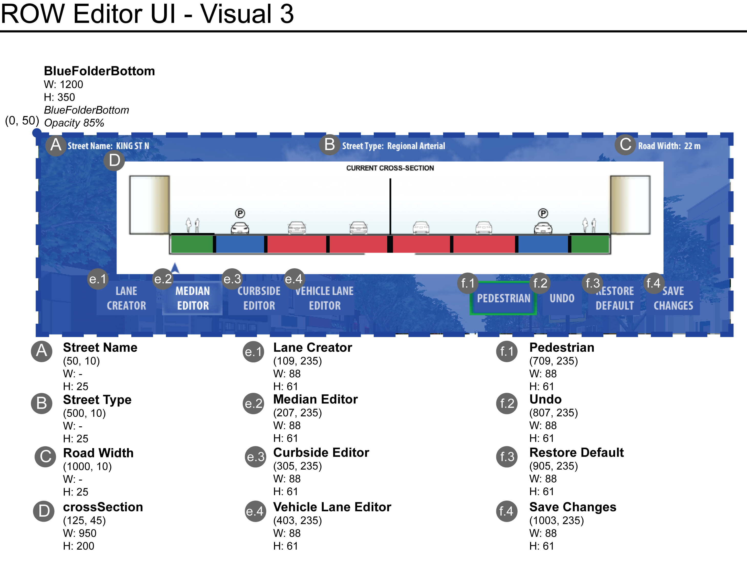

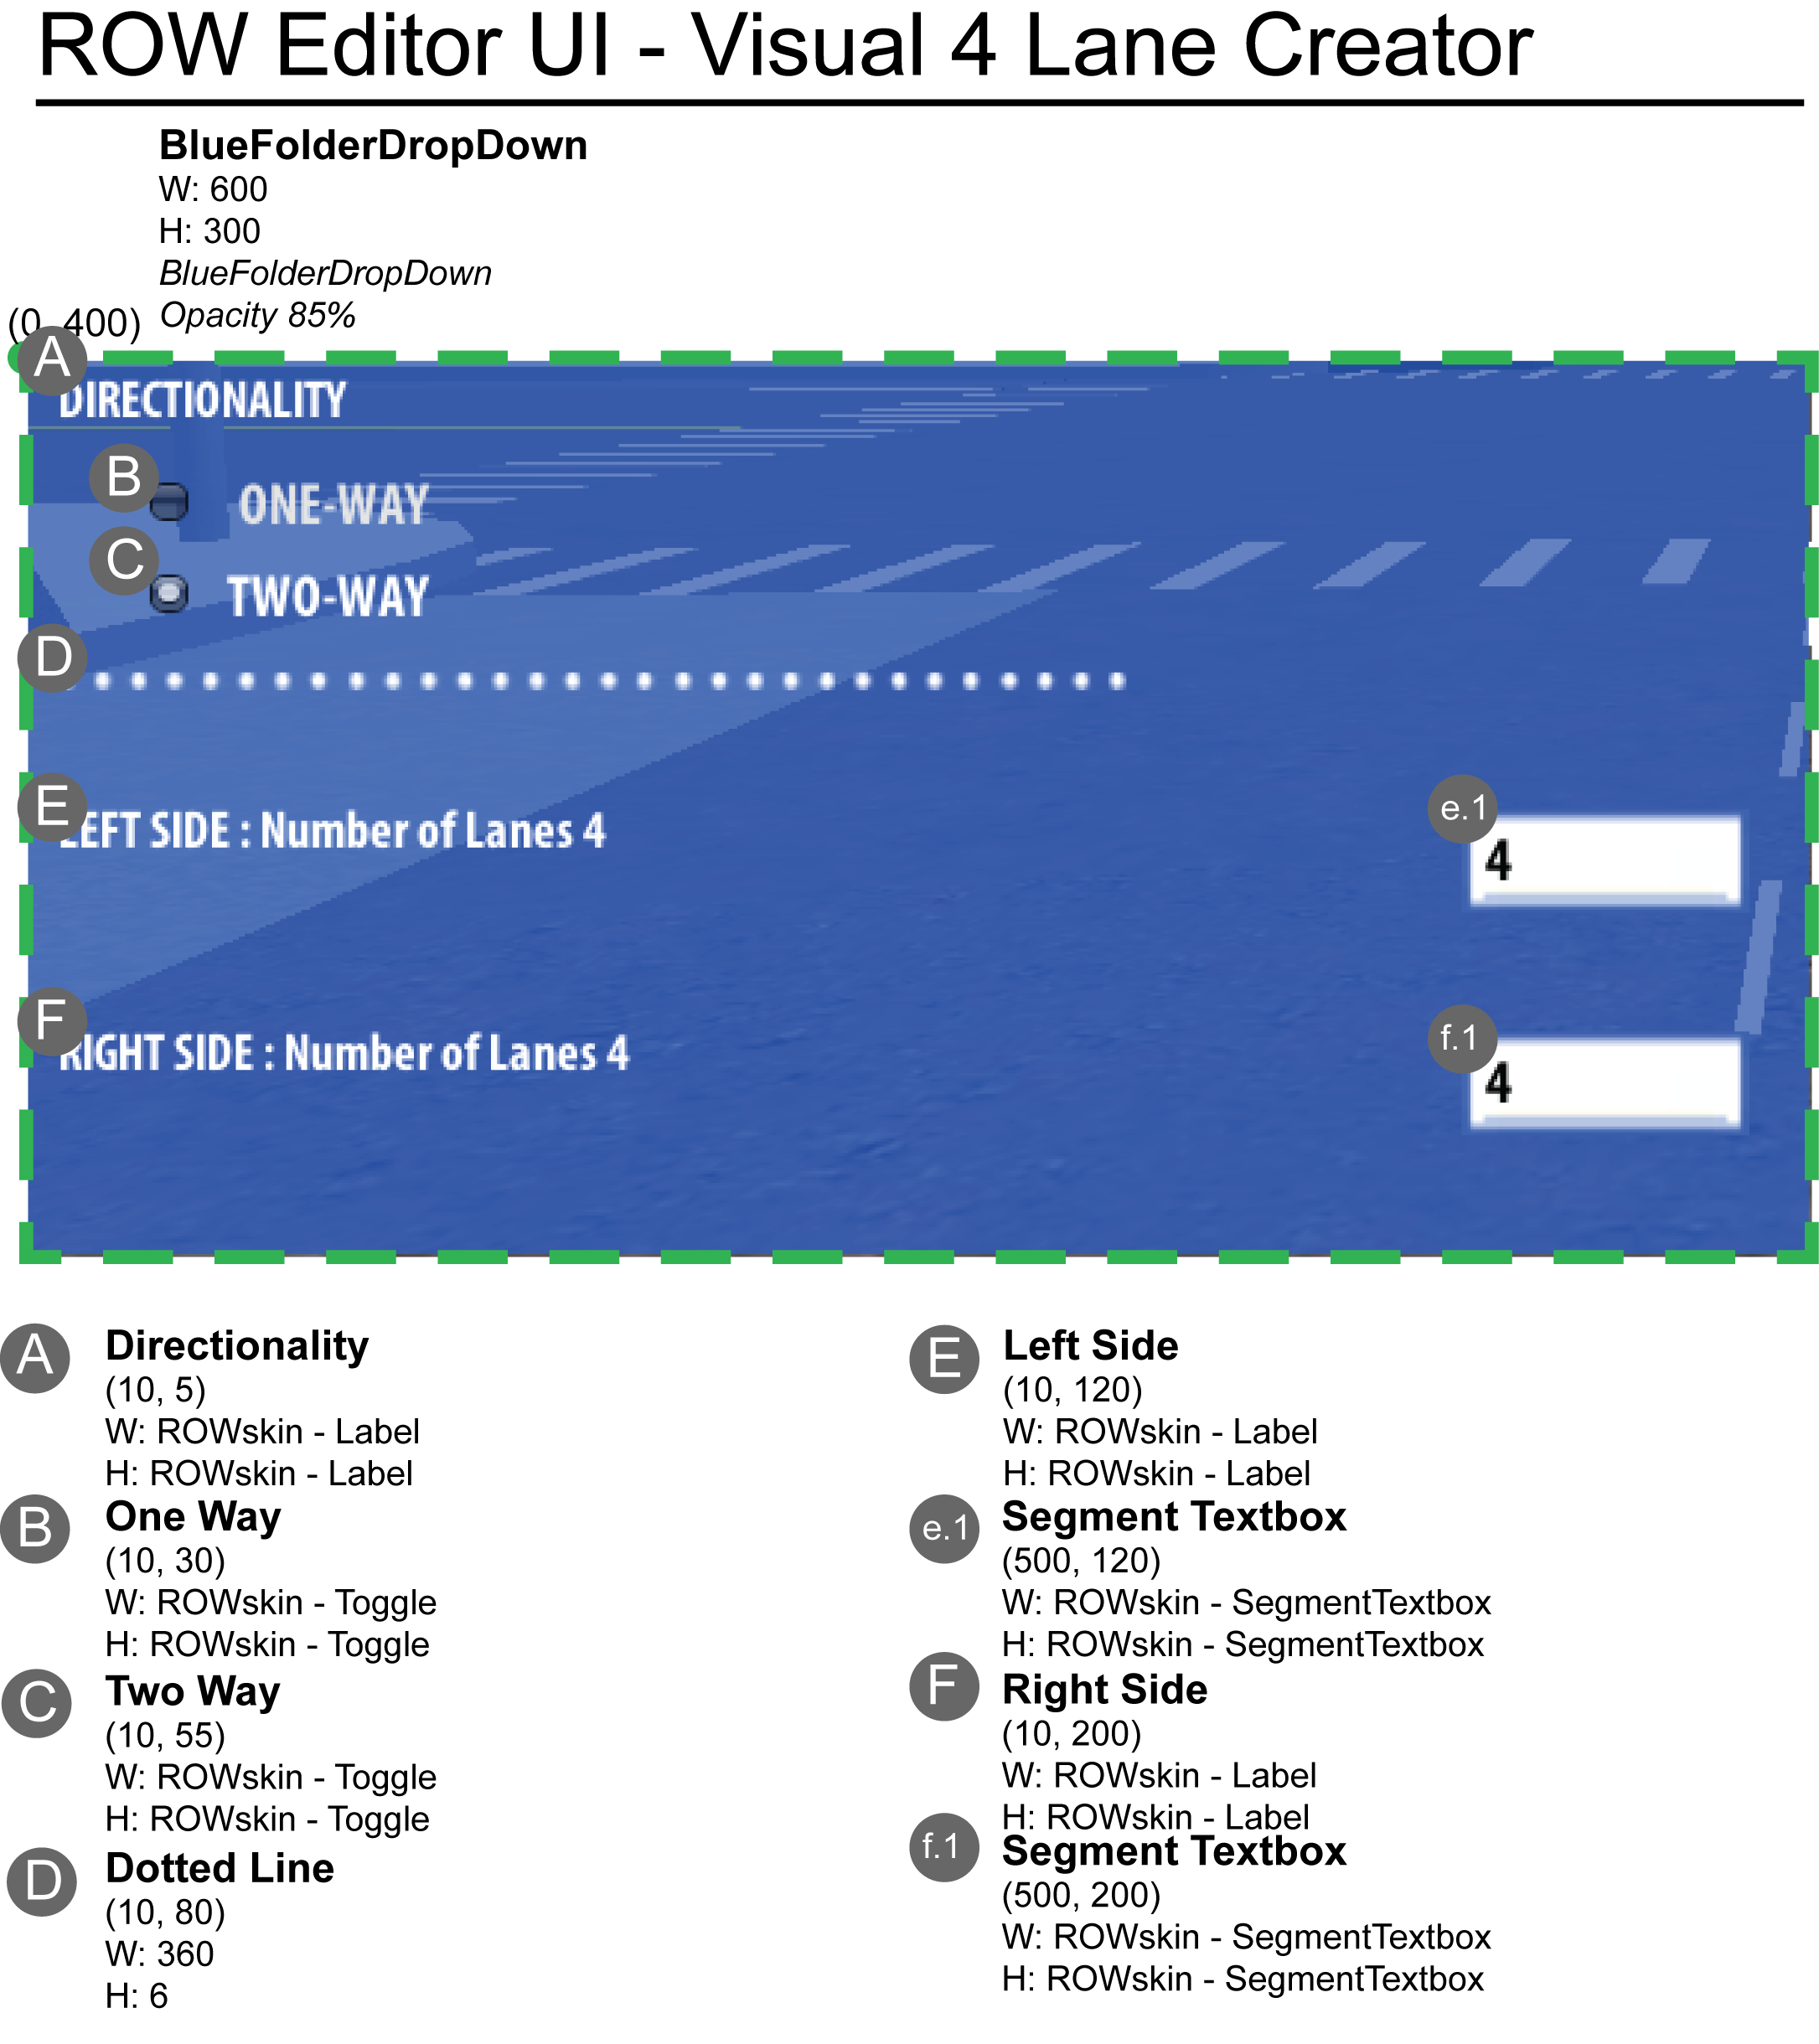

The 4 buttons on the left are made of a GUILayout function called **SelectionGrid**. This button styling allows only one button to be active any time. This is ideal because the user can only work on one Editor at a time.

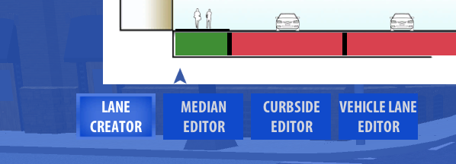 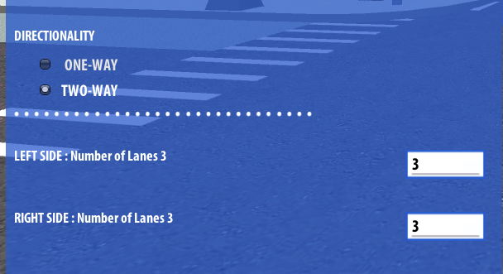

When one button is selected, a corresponding function is called to draw the respective editors. There are a few notes on that:

1. If the road segment is not initialized, only the Lane Creator is shown
2. After the road segment is initialized, user is able to select the different road elements by clicking on the color blocks underneath the icon.
3. The corresponding Editor will be automatically switched to with the appropriate settings after the user clicks on the color block.
4. If the user clicks on the other editor while selecting on a color block, it implies that the user is changing the type of the particular road elements. For instance, if the user wants to change a Car lane to a Parking lane, he/she would first select the target color block and then select the **CURBSIDE EDITOR** with the Parking option.

The 4 buttons on the right are: **Pedestrian**, **Undo**, **Restore Default** and **Apply Changes** function buttons.

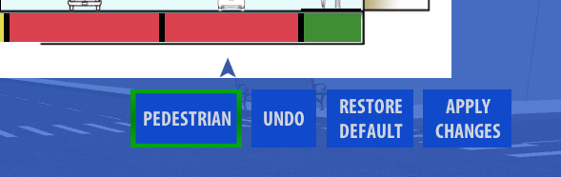

The functionalities of the buttons are already described in the Hierarchy Documentation. Here, we shall dive into the mechanism of these functions.

**Pedestrian**

The **AvatarManager.js** script attached to the **AvatarHandler** game object manages all the pedestrian interaction. It contains different kinds of functions to control the pedestrian behavior; however, few of them are used by now. All of the pedestrian are generated under the game object AvatarHandler/Pedestrian and governed by the AvatarManager script. They are then sorted under the AvatarHandler by the corresponding road segment unity names they attached to. Thus, it makes the most sense to have the AvatarManager script to take care of all the pedestrian behavior.

The AvatarHandler will be further elaborated in the later section.

**Undo**

The undo function is one of the important functions of the RightOfWay Editor. It contains 3 variables to be functional: **numRowsOfUnredoList**, **unredoList** and **listPointer**. We call it a unredo list because it is possible to implement a redo function on it as well.

numRowsOfUnredoList returns the number of histories the user has made during the interaction. The histories are stored under the Resource folder (*/Assets/Resources/Temporary Data/Roads/…*). They are organized by the unity name of the road segment. By default, the numRowsOfUnredoList is set to -1 (to extract the entire histories).

unredoList contains an array of histories of the road segment. It is reloaded every time a change is registered. The size of the unredoList is determined by the actual number of histories extracted from the Temporary Data (i.e. it is not necessary to be the same as the numRowsOfUnredoList).

listPointer points to the previous action made by the user on the unredoList. Thus, when the unredoList is reloaded, it points to the second last entry, where the last entry usually refers to the last change made by the user.

When the undo button is clicked, the **LoadRoadSegment** function of the **RoadSegmentMain.js** script is used to instantly refresh the 3D world. The parameter used by the LoadRoadSegment function is an entry of the unredoList (string) referenced with the listPointer. The format of the string will be described in later section. After the 3D world is refreshed, the local copy of variables in the RightOfWayUI.js script is synchronized again with the InstantiateRoadElements.js script to ensure that the cross section is drawing the current 3D world.

**Restore Default**

There are implications behind the Restore Default function. If the user is using the preset (where the user is always using the preset for the current IRUS version), the default setting will be the preset. If the user is not using the preset, the default setting will be the initial state determined by the **InitializeRoad** function in the RoadSegmentMain.js script.

Due to the multiple segments issue created by the CityEngine, we will have to restore the default setting for all of the road segments in the same block as well. Finally, a restore default action is considered to be a change, thus the unredo list is reloaded.

Note that the undo function does not update all of the road segments in the same block. The idea behind that is to allow the user to compare the road segment with the adjacent one. Once the “Apply Changes” button is clicked, the change will be applied to all of the road segments as well.

**Apply Changes**

When the user hits “Apply Changes”, IRUS grabs the latest change in the temporary data and appends it to the user data. Same as the restore default function, “Apply Changes” is considered to be a change, thus the unredo list is reloaded.

**Close and Preview Button**

To close the RightOfWay Editor, The only way to do it is through the close button on the top right corner of the editor.

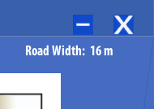

Before the editor is closed, one thing has to be checked. If the user has not yet saved the changes (indicated by the changesMade variable), the RightOfWayUI.js script grabs the latest change in the User Data and reloads it to the world. The same is done to the multiple segments in the same block.

From the above figure, you can see the Preview button (minus sign) as well. This is just to allow the user to minimize the RightOfWay Editor.

**Cross Section Area**

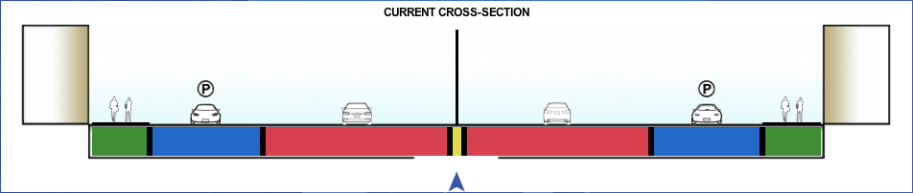

The cross-section area has become the major interaction with the road segment after we introduce the color blocks and the boundary selector. User can click on the color block to select the road element and drag the boundary selector to adjust the relative widths of the two adjacent road elements. The drawing of the cross section is refactored inside the function **DrawOnCrossSection**.

(Note: The algebra is a little bit of disastrous here because the cross-section image is stretched when created in the RightOfWay Editor, we have to add and minus a few pixel to position it properly. Although it is functioning perfectly, it will be appreciated if the future coops will tidy it up.)

Besides drawing the color blocks (buttons) and the road elements icons (Texture2D), one of the important functions of the cross section is to limit the extents of which the user can adjust the relative widths. To fully grasp the underlying mechanism of the cross section, a few concepts should be mentioned:

1. To draw the boundary selectors, we need the corresponding offsets of the road elements so that the ratio appeared in the cross section will be corresponded to the 3D world. The **currOffset** array contains the offset values of the road elements from the start (0) to the offset between the last and second last road elements (road width – width of last road elements).
2. The cross section is drawn from left to right and so as the order of the currOffset elements.
3. To check if the minimum width of a road element is approached, we need to check the corresponding type of the element. The related information can be found in the variables: **leftWidths**, **leftTypes**, **medianWidth**, **medianType**, **rightWidths**, **rightTypes**, **numSegmentsLeft** and **numSegmentsRight**. And the function used is **ReturnMinWidth**.

The main idea is when the user drags a boundary selector (a mouse down event is recorded), the script checks to see which direction is the user dragging to by comparing the calculated offset of the dragging boundary selector and the original position of the selected boundary selector. After verifying the direction, it then checks if the decreasing width (the color block that is shrinking) approaches the minimum width yet. If yes, then we update the respective widths; if no, then we throw an error.

Only after the user finishes dragging (a mouse up event is recorded), the script then registers a change.

Note that: the script updates the **leftWidths** and **rightWidths** variables immediately while dragging because it needs these variable to draw the cross section area.

**Color Blocks**

Besides making the cross section more visual appealing, the color blocks system also helps the grouping of the road elements. The color blocks scheme is listed below (see the function **ReturnLaneTypeColor**):

All traffic lanes in Red Rect

All median elements (only for two-ways street) in Yellow Rect

Sidewalks and Green Space in Green Rect

Parking lanes and bike lanes in Blue Rect

For example, the Curbside Editor checks the selected color block to see if the type change is valid. If the selected block is a “Yellow Rect”, then the change is not permitted (Cannot add a curbside element on a median).

**Slider**

Here, we want to introduce the slide in the cross section area.



The slider acts as a pointer to the selected color block. In fact, the user is able to drag the slider to select the road elements as well. However, the slider serves a more important function then just an indicator. There is a variable named **currPos**. It represents the position of the horizontal slider.

Developer may notice that the slider only stays in the center of the color blocks. This effect is created by the function **OnWhichSegment**. This function checks to see what range of the currOffset elements (array of road elements offset mentioned above) is the currPos fell into, then set the currPos to the center of the road element.

The **currPos** is often used to check which road element is the user currently selecting. For example, the function **ReturnSelectedInfo** returns a wide range of information using the value of currPos. It finds the currPos and returns a specific piece of information of the selected segment.

**Instruction Message Box**





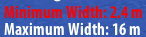

There are currently three types of message being shown in the RightOfWay Editor: the instruction message, the error message and the alert message.

The instruction message and the error message are drawn in every OnGUI function using the variable **instructionMsg**. To throw an error message, prepend the string “Error: ” to the instructionMsg. This will change the GUISkin used when drawing the instruction message. The functions being used are **InstructionMessageType** and **InstructionMessage**.

For the alert message, the script uses the function **TickerTimer** to set the duration of the alert message. Please refer to the script for details.

Now, we are going to gradually move the documentation to the **Backend-related** functions.

**EditSegment**

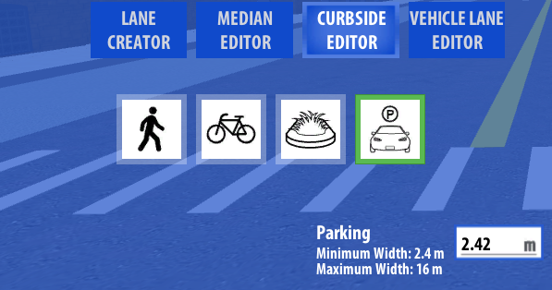

The three editors all have a similar layout and functionality. The corresponding icons present the different types of road elements; the minimum and maximum width is listed besides the textbox to input the road element widths.

The textbox provides a more precise way to adjust the width of the road elements. After typing in the desired value, the user hits “Enter” or “Keypad Enter” to register the value. Then, the EditSegment function will be called to check if the change is valid. Because the EditSegment function is written before we revolutionize the cross section area, some of the calculation may seem tedious.

Nevertheless, it finds the selected segment using the currPos and uses the calculated width difference from the input to see if the change is valid. If the selected segment is expanding its width, then **EditSegment** checks recursively the next road elements (towards the median) if there is enough space using the function **CheckEnoughSpace**. If not, then the change is reverted.

To enhance the flexibility when the user selects the segment closest to the median (i.e. no more road elements to accommodate the width), we check the one segment before it.

When editing the median width, the function will consume the two widths besides it (i.e. leftWidths [leftWidths.length – 1] and rightWidths [rightWidths.length – 1]).

**UpdateLocalChange**

After each change is verified to be valid, it will then be verified by the function **UpdateLocalChange**. This function updates all the local variables in the RightOfWay Editor to the InstantiateRoadElements script that is attached to each road segments. The 3D world will be refreshed with the new variables. In addition, the function RedrawIntersectionSidewalk will be called to draw the circular sidewalk in the intersections.

For the current IRUS version, only intersections on King Street with 4 junctions will be drawn. Here comes to the end of the **RightOfWayUI.js**, the mechanism of the intersection drawing will be discussed in the next section.

**InstantiateIntersections.js (***/Assets/IRUS Scripts/Road Segment Scripts/***)**

We choose to talk about the InstantiateIntersections script first because the structure is simpler and similar to the more complex **InstantiateRoadElements.js** script.

*Before and after drawing the intersections*:

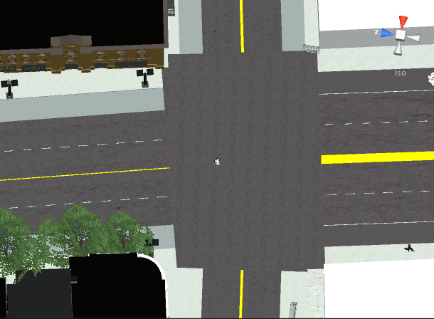 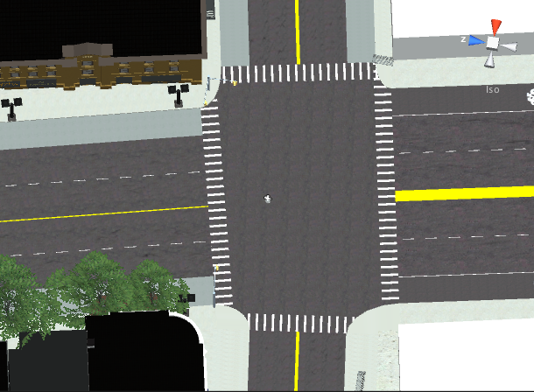

From the above figures, they reveal two important functions of the InstantiateIntersections script. It draws the circular sidewalks (it uses the CircularCurb prefab) and crosswalks of the intersection. The intersection drawing is done by the public function ModifyIntersection. This function is called every time the intersection needs to be redrawn. In this section, we will mainly talk about the mechanism of the intersection drawing.

First of all, a few important concepts about the **Mesh Filter** of a game object in Unity should be reminded before we proceed:

1. Any physical observable game objects in Unity contains a **Mesh Filter**, which takes a mesh from the game object and passes it to the **Mesh Renderer** for rendering on the screen. In the inspector, the Mesh Filter and the Mesh Renderer are two separated components (i.e. an object can have a mesh filter without rendering it on the screen).
2. The (Mesh) **Collider** is what gave “**mass**” to the game object so that one cannot walk pass it.
3. The Mesh Filter contains a property named **Mesh** that is a reference to a mesh that will be rendered. Scripts can modify this Mesh with the Mesh class. ([**http://docs.unity3d.com/Documentation/ScriptReference/Mesh.html**](http://docs.unity3d.com/Documentation/ScriptReference/Mesh.html))
4. There are 3 main variables that compose a Mesh and can be access and modify by code:
   1. **Mesh.vertices** – this is an array of a Vector3 that represents the coordinates of the vertices of the Mesh
   2. **Mesh.triangles** – the triangles is an integer array containing all the triangles in the mesh. One triangle is made of 3 vertices so the size of the triangles array must always be a multiple of 3. The integers in the triangles array refer to the indices in the Mesh.vertices array.
   3. **Mesh**.uv – This is a normalized 2D coordinate system (UV [W]) to assign textures to a mesh. The UV is seldom used in the IRUS project.

Back to the simpler problem of drawing the intersection, only the vertices array is used.

Throughout the entire IRUS project, developers may notice that there is not really an absolute direction assigned to any elements because that is unnecessary. Before the circular sidewalk (prefab) is drawn, we need to define a position for the center of the circle. These center points are contained by the **intersectionPoints** array. The circular prefab is instantiated at the intersection point with one of the axis pointing at one of the sidewalk intersections.

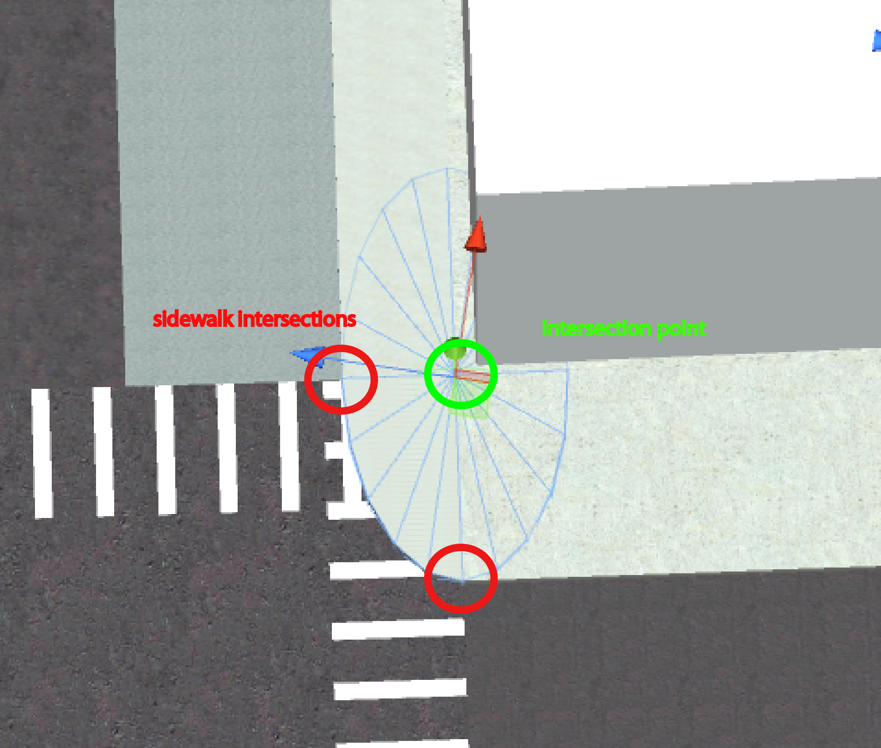

The x and z (instead of y in Unity) axis of the circular prefab are then scaled by two times of the distance between the intersection point and the two sidewalk intersections. The reason behind the two times scaling is because we are scaling the diameter of the prefab instead of the radius. And the y-axis scaling is done experimentally.

Here, let’s take one step backward and talk about how are the intersection points found.

2 public arrays are populated from the database on start. They are the **intersectionStreets** (street names) and the corresponding **intersectionStreetsUnityName** (unity names of the street names) attached to the intersection. Thus, the number of junctions of the intersection will be the size of either of these arrays.

The intersectionStreetsUnityName array is used to find the road segment game objects in Unity that are attached to the intersection. These road segment game objects contain the **InstantiateRoadElements.js** script that has 3 variables related to the intersection drawing: **vertices** (Vector3 []), **intersectionEndPointsA** (Hashtable) and **intersectionEndPointsB** (Hashtable). The **vertices** contain the vertices of the road segment; the intersectionEndPoints A and B, with the corresponding **keys** and **values**, contain the position and type of the points at the two ends of the road segment. Below shows a simplified diagram of the road segment:

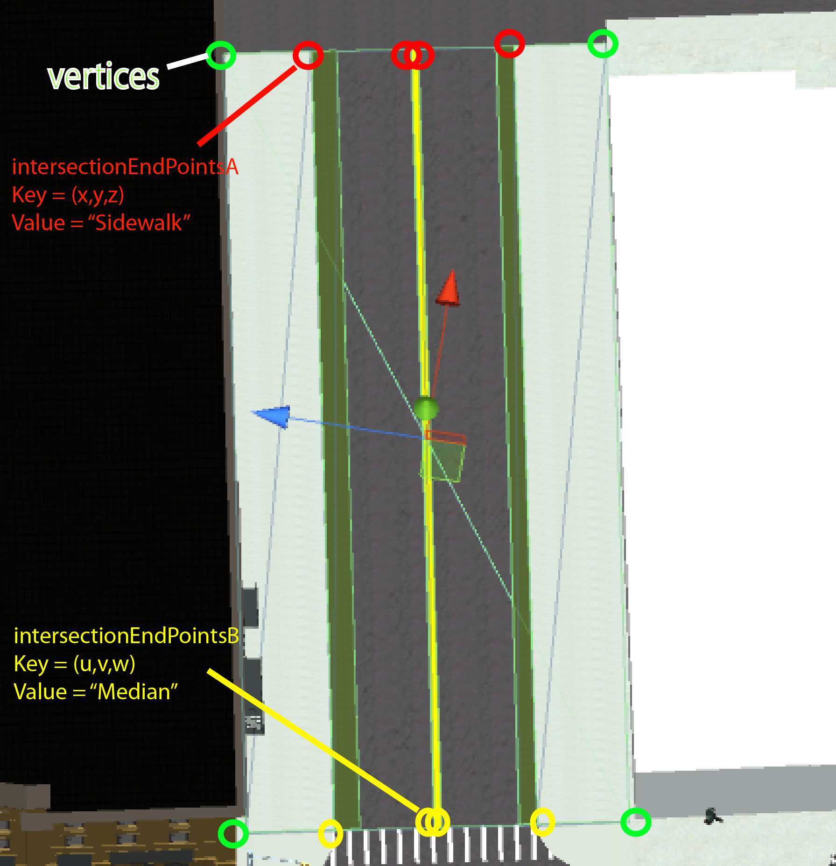

Hopefully it is clear from above that the intersectionEndPointsA and B represent the end points of the two sides of the road segment.

For the InstantiateIntersections to find the intersectionPoints, it first has to find the two closest **vertices** to the center of the intersection. The center of the intersection is calculated on start in the **createEdgesArray** function. The two closest vertices then construct a Line, which is defined by the Line Class in the **Parcel.js** script. It is recommended to go through the Line Class in the Parcel script. There are a lot of useful functions contributed by different coops.

For each road segment connected to the intersection, there will be one Line joined by the two closest vertices. These Lines are then pushed to the **intersectionLineArray**. Meanwhile, the script will compare the points (key of Hashtable) in the intersectionEndPointsA and B to check which array should be used. Once verified, the corresponding points will be copied over.

After the intersectionLineArray collects all the Lines, they are then sorted in cyclic order. Eventually, the static function **LineIntersectionPoint** in the Line Class will be used to calculate the intersectionPoints from the intersectionLineArray. The LineIntersectionPoint function calculates the intersection points of two given Lines.

Although this point-searching model works seamlessly in the current IRUS version, we would like to point out one limitation of it as well. When the script tries to find the two closest vertices of the road segment, if the center point is for some reasons shifted to one side of the intersection and there are more than two vertices on one side of the road segment, a different set of vertices may be selected which would cause the intersection to be drawn incorrectly.

Next, we are going to talk about how the InstantiateIntersections draws the crosswalk. The crosswalk drawing utilizes the **intersectionLineArray** mentioned above.

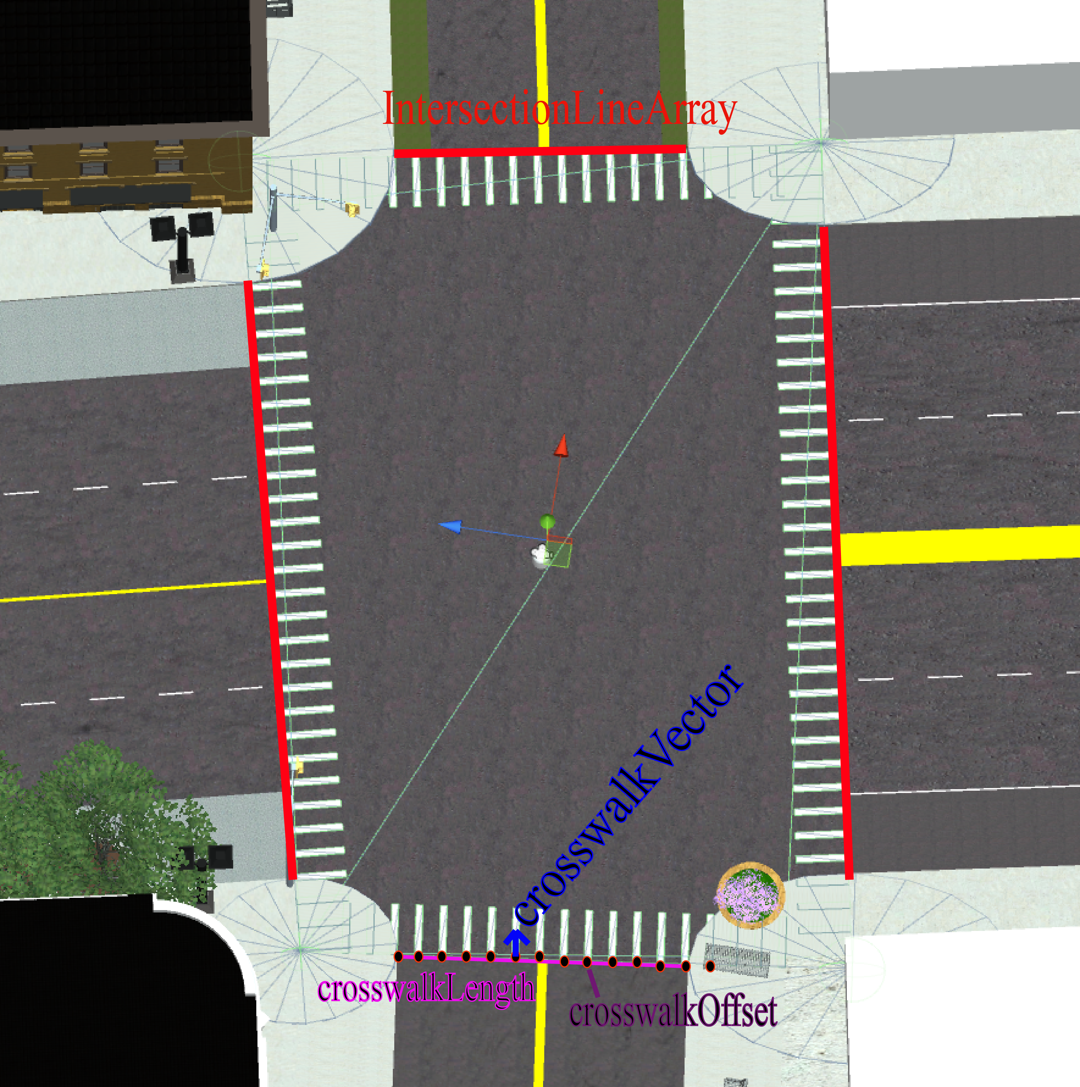

The above figure is the pictorial explanation for the function **DrawCrosswalk**. Put it in the simplest words, the **crosswalkOffset** is iterated through the **crosswalkLength**. For every iteration of the crosswalkOffset, a white line (DottedWhiteLine prefab) is instantiated at the position (crosswalkOffset – **crosswalkVector**). The position is the center of the DottedWhiteLine prefab.

**InstantiateRoadElements.js (***/Assets/IRUS Scripts/Road Segment Scripts/***)**

The **InstantiateRoadElements.js** script is similar to the InstantiateIntersections script. It contains a public function named **CreateRoadElement** that is called every time when the road elements on the road segment in the 3D world needs to be redrawn. In addition, **Pedestrian** is created in the CreateRoadElement function when a sidewalk is drawn.

The CreateRoadElement function draws/instantiates one road element at a time. Thus, the number of times being called depends on the road elements on the road segment. If the road segment contains 2 parking lanes and 2 sidewalks, then it will be called 4 times. The CreateRoadElement function draws the road element at the position of **offsetx** away from the reference line. This reference line is contained in the **filterEdgesArray**. The filterEdgesArray is analogous to the crosswalkLength mentioned above in the **DrawCrosswalk** function.

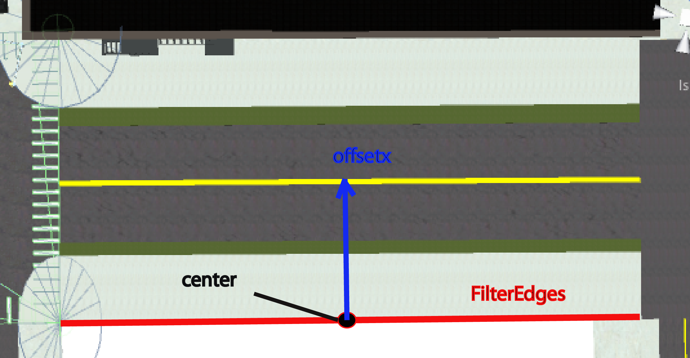

In normal circumstance, there should be only one FilterEdges. The road element is then instantiated with offsetx away from the center point. The CreateRoadElement function also adjusts the tiling ratio of certain road elements like the Turning Lane and the Bike Lane.

As mentioned in the InstantiateIntersections script, the intersectionEndPointsA and B are refreshed every time a road segment is redrawn. This is to make sure the end points values reflect the current road segment condition.

Besides the different things mentioned above, the CreateRoadElement has one more thing to take care of. The Urban Design Editor utilizes sidewalks to instantiate street furniture. That is, every time when the road elements are redrawn and the sidewalks are instantiated, the function needs to restore the functionality of the sidewalks in order for the Urban Design Editor to work.

Every sidewalk in IRUS contains a script named **Group**. The Group script contains a mouse down event that will interact with the Urban Design Editor. Thus, the Group component has to be added every time a sidewalk is instantiated. In addition, we will have to restore the existing condition of the sidewalk. For example, if there is two “Classic Benches” on the sidewalk, they need to be recreated every time. The InstantiateRoadElements script contains 4 Boolean variables to control this:

1. containUserDataSidewalkLeft
2. containPresetSidewalkLeft
3. containUserDataSidewalkRight
4. containPresetSidewalkRight

These 4 Booleans tell whether is there an Urban Design Objects to instantiate when the sidewalk is instantiated. If there is an object on sidewalk left (containUserDataSidewalkLeft = true), then the changes will be extracted from the user data. If not, the script will check if there is a preset contained (containPresetSidewalkLeft = true). If there is no preset, then no object will be created. The same principle goes for the SidewalkRight.

**RoadSegmentMain.js (***/Assets/IRUS Scripts/Road Segment Scripts/***)**

The next script we are going to talk about is the **RoadSegmentMain.js** script. This is the script that manipulates the **CreateRoadElement** function in the **InstantiateRoadElements** script. It contains function to initialize road segment, to instantiate all the road elements of the road segment in 3D world, to encode the variables provided by the RightOfWay Editor to a string and store it into the temporary data and to manage all the 2D textures being drawn on the cross section of the RightOfWay Editor.

Let’s start with the function that updates the road segments in the 3D world: **UpdateRoadElements**.

The UpdateRoadElements function first destroys all the existing road elements on the target roadSegment, then takes all the variables related to a road segment and calculates the respective offsets (**offsetx**) and use the CreateRoadElement function to instantiate them in the 3D world. In addition, it updates the InstantiateRoadElements script with the input variables.

On top of that, the UpdateRoadElements function draws lines to separate different vehicle lanes. For example, any traffic lanes will be separated by dotted white line (DottedWhiteLine prefab) and a white line (WhiteLine prefab) will be used to separate a bike lane and a traffic lane.

The **InitializeRoad** function uses the UpdateRoadElements function as well, but the settings (input variables) are predefined by the road width.

There is also one useful function named **LoadRoadSegment**. This function takes in a database string and decodes it to feed into the UpdateRoadElements function. Thus, if there are any changes to the format of the data string, this should be the function to modify. The Undo and the Restore Default buttons of the Right Of Way Editor constantly call this function.

In opposite to the LoadRoadSegment, there is the **addDataToUserTable** function. This function encodes the variables to a data string and updates it to the database. If developers wish to change the format of the data string, this should be the function to modify.

All the road elements prefabs and 2D textures on the cross section area of the RightOfWay Editor are controlled by the functions **GetPrefab**, **ReturnTexture** and **ReturnAccessoriesTexture**.

**CreateAllRoads.js (***/Assets/IRUS Scripts/Road Segment Scripts/***)**

Now we have gone through most of the frontend scripts of the RightOfWay Editor, let’s move to the backend scripts. The CreateAllRoads script serves as a middleman between the frontend and the backend. It is used heavily on the start and contains all the data from the databases. Because the time it takes to initialize the road segments and intersections rely heavily on this script, it controls the fading in and out effect when entering a scene. The rationale behind is to start the fading once the roads are initialized.

(Note: since the database in theory can be extracted from the web server, the yield function must be used to control the timing. However, the yield function cannot be used on **Awake** or **OnEnable**, thus we could only start processing the database on **Start**)

Roughly speaking, there are **static** data and **dynamic** data in IRUS. Static data refers to data that will not be changed by users. For instance, the street name and type of the road segments and the unity name of the road segments and intersections. These data are all written in a csv file, which can be opened by Microsoft Excel. Dynamic data refers to data that can be overwritten by users. They are the temporary data, user data and the preset data of the RightOfWay Editor and the Urban Design Editor.

The static data is processed by the two functions **ProcessRoadDatabase** and **ProcessIntersectionDatabase**. Please note that the ProcessIntersectionDatabase function must be called after the road segments are initialized. This is because the ProcessIntersectionDatabase function draws the intersections and drawing the intersections requires the sidewalks to be instantiated.

The order of the initialization is listed below:

1. Process Road Database
2. Get Urban Design Object Preset Data
3. Get Urban Design Object User Data
4. Initialize Road Segments (either use preset or settings in the InitializeRoad function)
5. Load Road User Data (overwrite the initialized roads)
6. Process Intersection Database and Modify the Intersection
7. Fade In

For 2) and 3), the **GetUrbanDesignObjectsPresetData** and the **GetUrbanDesignObjectsUserData** do not actually instantiate the urban design objects, but they simply set the 4 Booleans: **containUserDataSidewalkLeft**, **containPresetSidewalkLeft**, **containUserDataSidewalkRight** and **containPresetSidewalkRight**. Only when the sidewalk is instantiated, the urban design objects are then instantiated.

There is a public function named **FindSegmentsInSameBlock**. This function is called by the RightOfWayUI.js to find the road segments in the same street block and the intersections attached to the road segments. Note that the CreateAllRoads contains a copy of the databases.

**StreetFurnitureUI.js (***/Assets/IRUS Scripts/GUI Scripts/***)**

As mentioned in the Hierarchy Documentation, the **EditObjectsUI.js** has already integrated with the **StreetFurnitureUI.js** (Urban Design Editor UI). Thus the EditObjectsUI.js script is no longer in use.

Although the functionalities of the Urban Design Editor UI sound the same as the RightOfWay Editor (the Undo, Restore Default and Save Changes), the mechanism behind is entirely different. Because the generated urban design objects are instantiated under the sidewalk object, the actual instantiation command is done within the sidewalk.

There are basically 4 levels for the entire system. From now on, we will refer the entire system as Urban Design Editor:

1. The **StreetFurnitureUI.js** works in parallel with the **ObjectLibrary.js** (*/Assets/IRUS Scripts/Urban Design Scripts/*), that provides the sorted prefabs, the 3 **UI**s and the **Backend** scripts.
2. The **Group.js** script (*/Assets/IRUS Scripts/Urban Design Scripts/*) that attaches to the sidewalk to manage all the children urban design objects under it.
3. The **SubGroup.js** script (*/Assets/IRUS Scripts/Urban Design Scripts/*) that manages all the urban design objects of the same type.
4. The **GenericObject.js** script (*/Assets/IRUS Scripts/Urban Design Scripts/*) that attaches to each urban design objects. It returns its position, rotation and scale when needed.

Unlike the RightOfWay Editor, the Urban Design Editor makes use of a lot of static variables because normally only one type of game object is being instantiated at a time and it has to be easily accessed by the 4 different levels. In this section, we will first discuss about the Urban Design Editor **UI**; then proceed to the **ObjectLibrary** that provides the prefabs; at last, we will explain in details how the 4 different levels interact with each other.

The functions of the StreetFurnitureUI and the integrated EditObjectsUI have already been explained in the Hierarchy Documentation; in the Scripts-side Documentation, we will talk about how the **StreetFurnitureUI.js** controls the entire Urban Design Editing process.

The UI of the Urban Design Editor is written in the GUI Class instead of GUILayout Class like the RightOfWayUI. The blueprint is attached below:

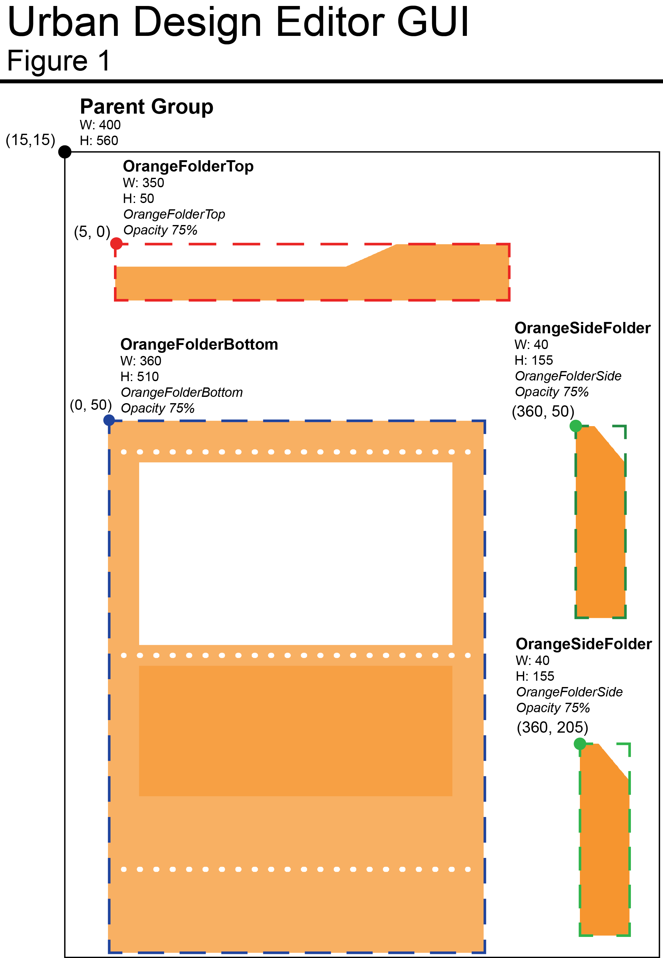

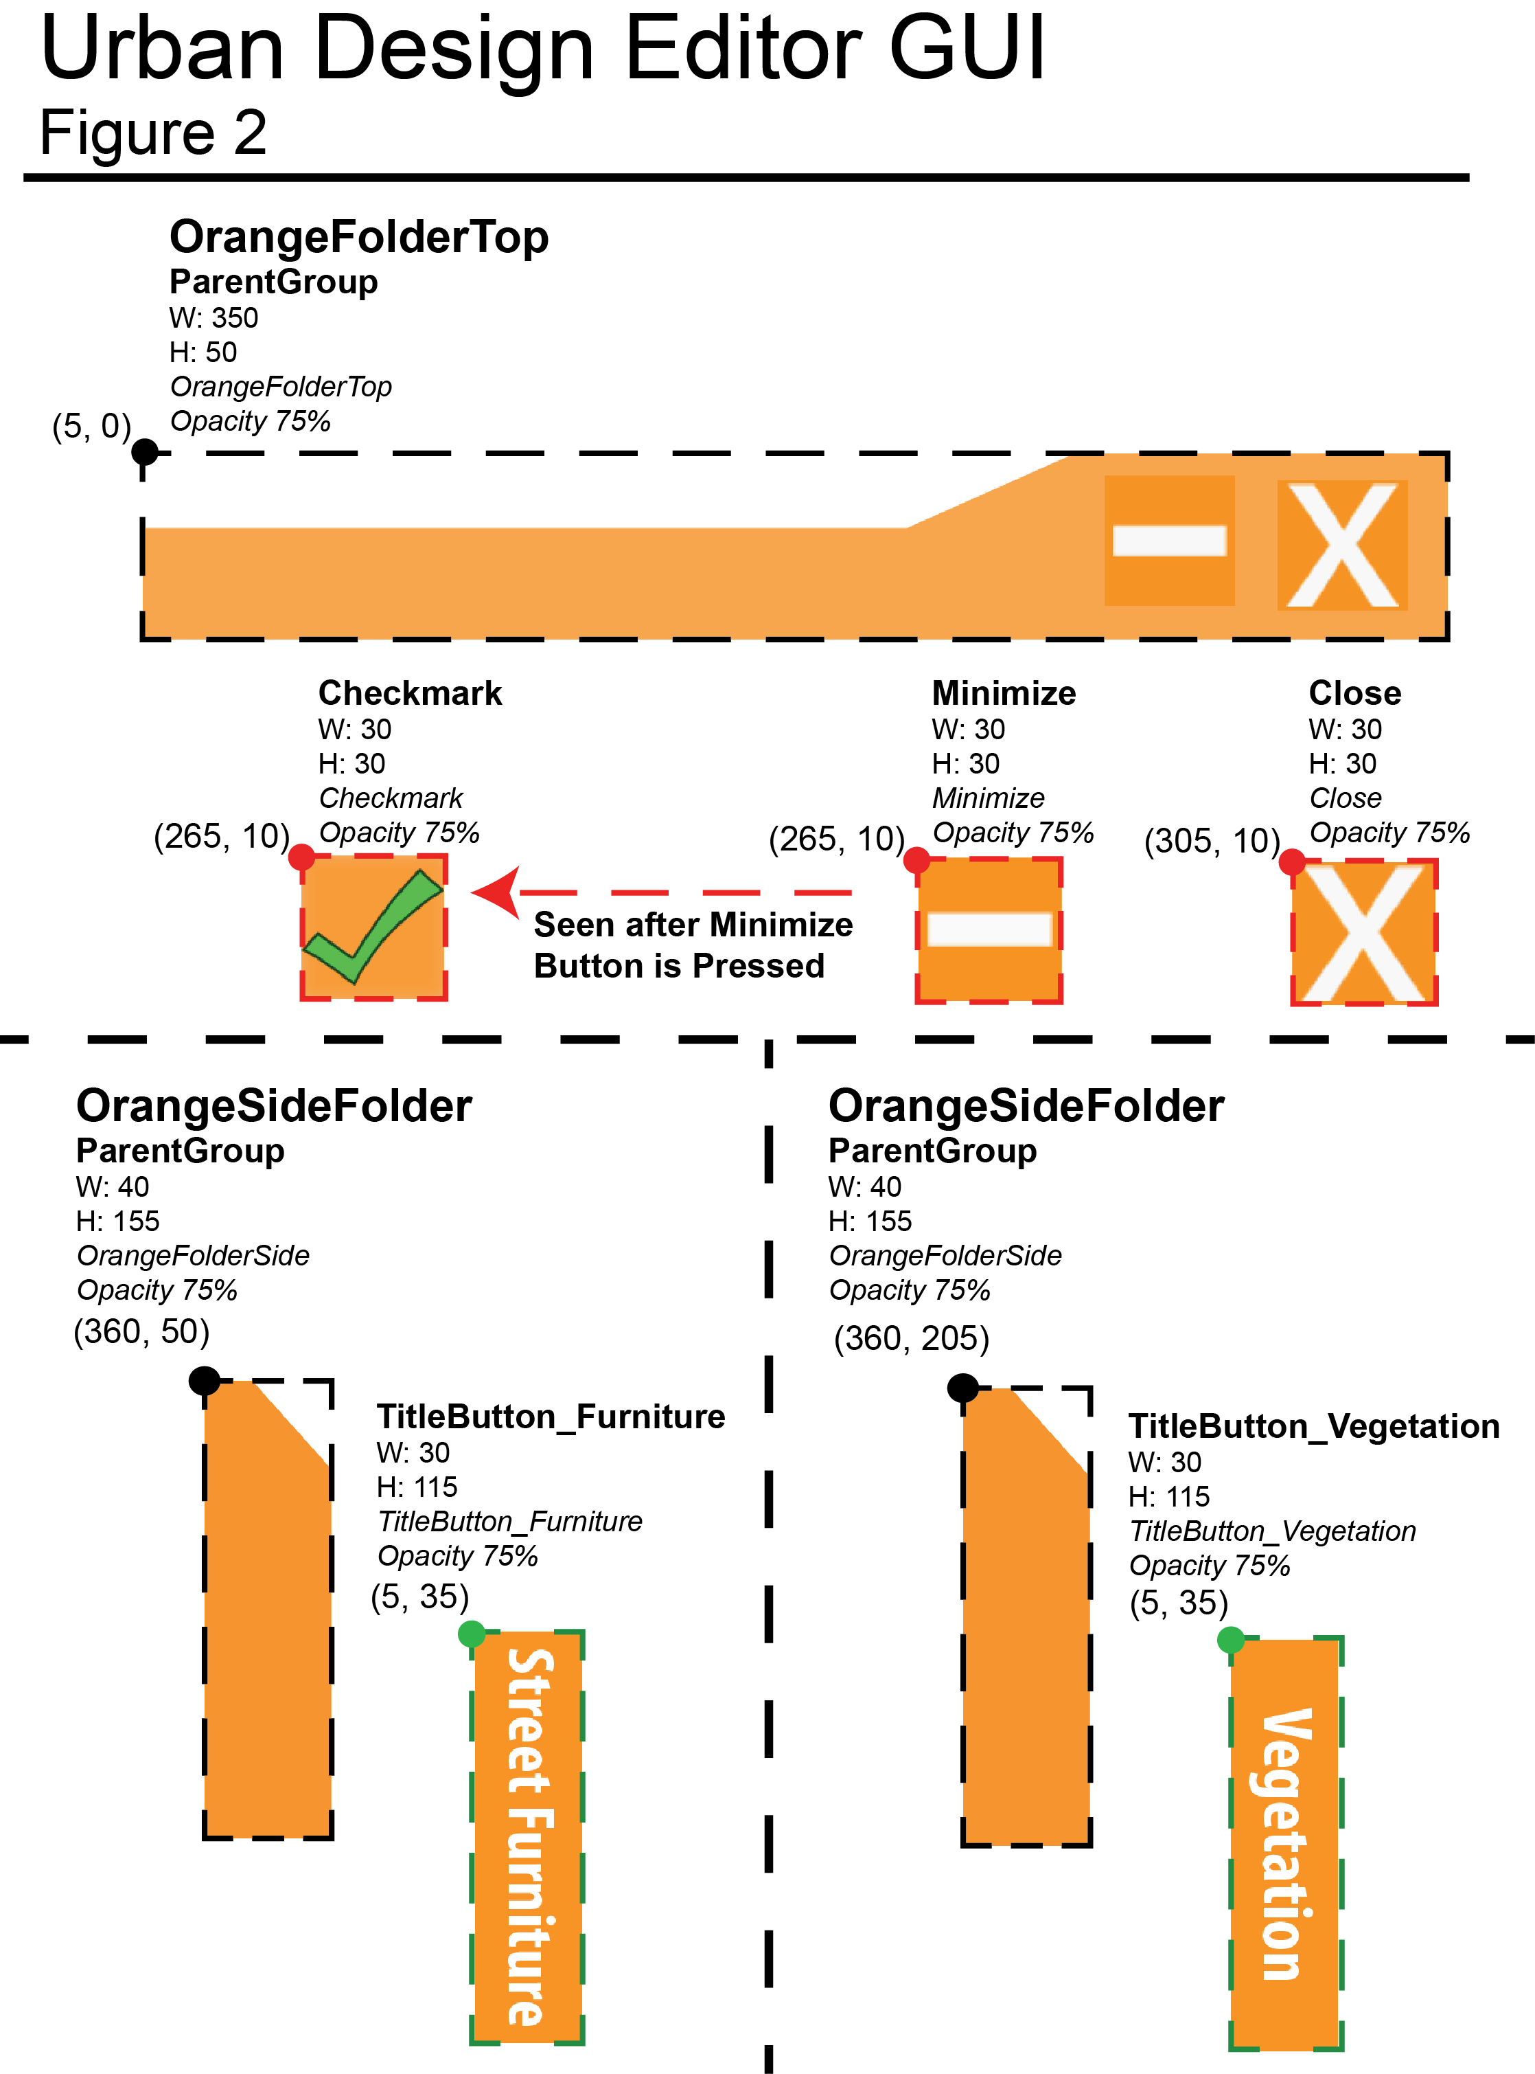

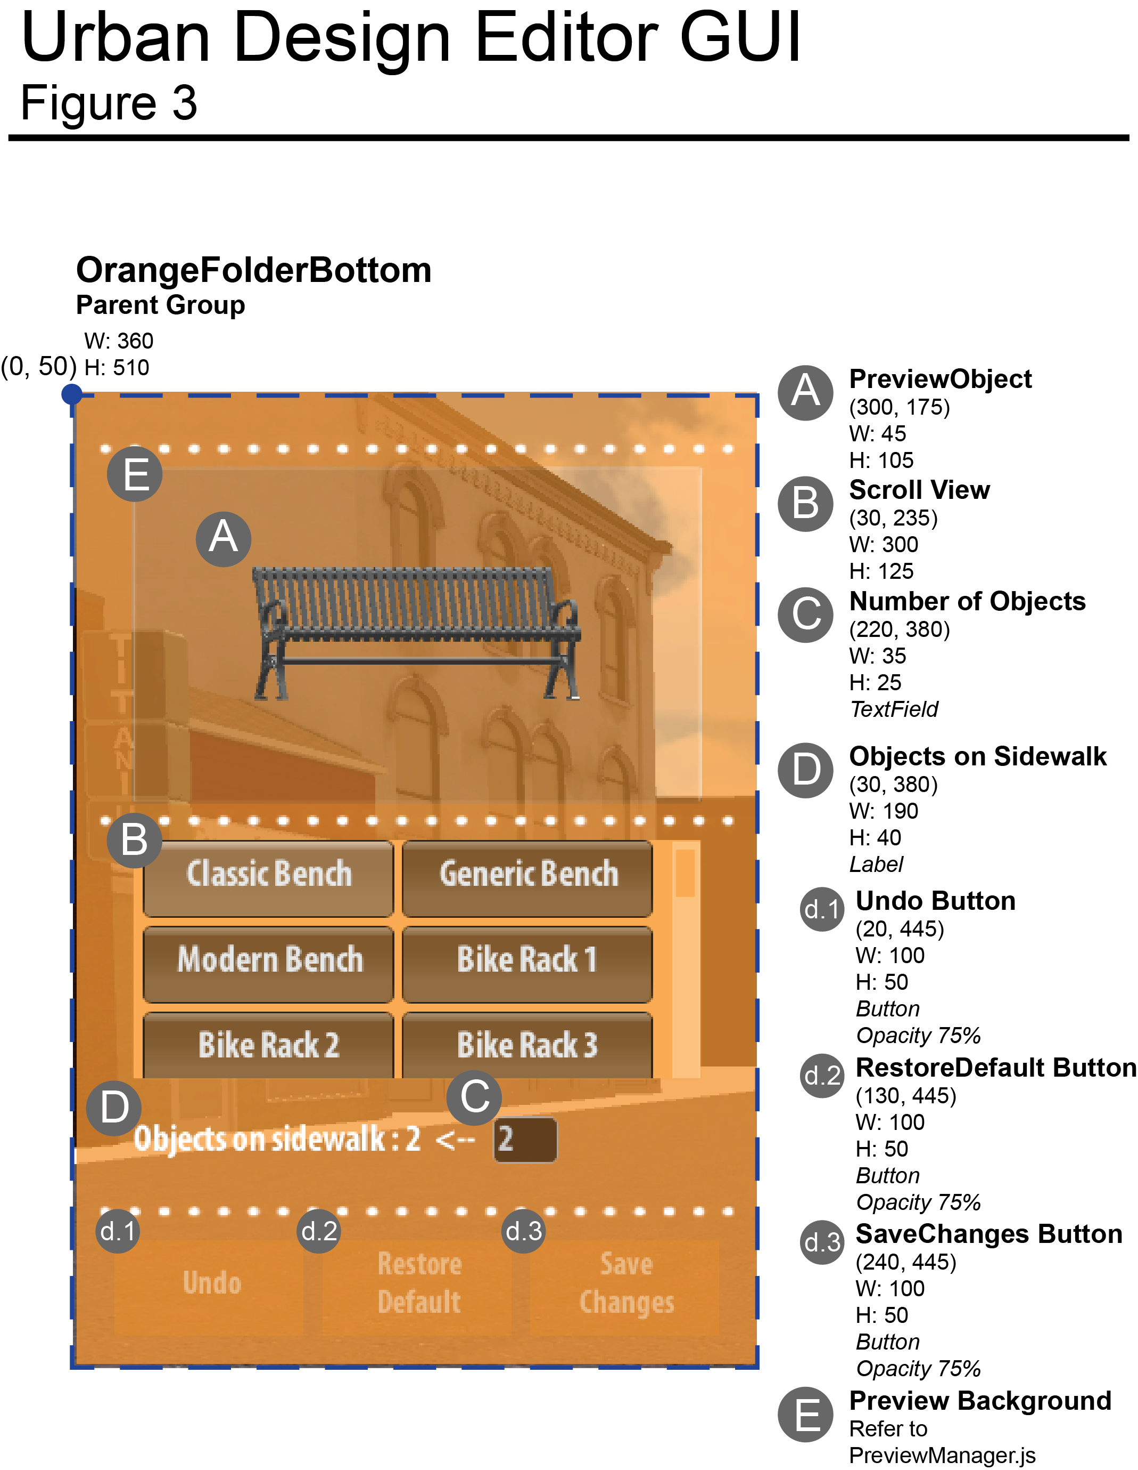

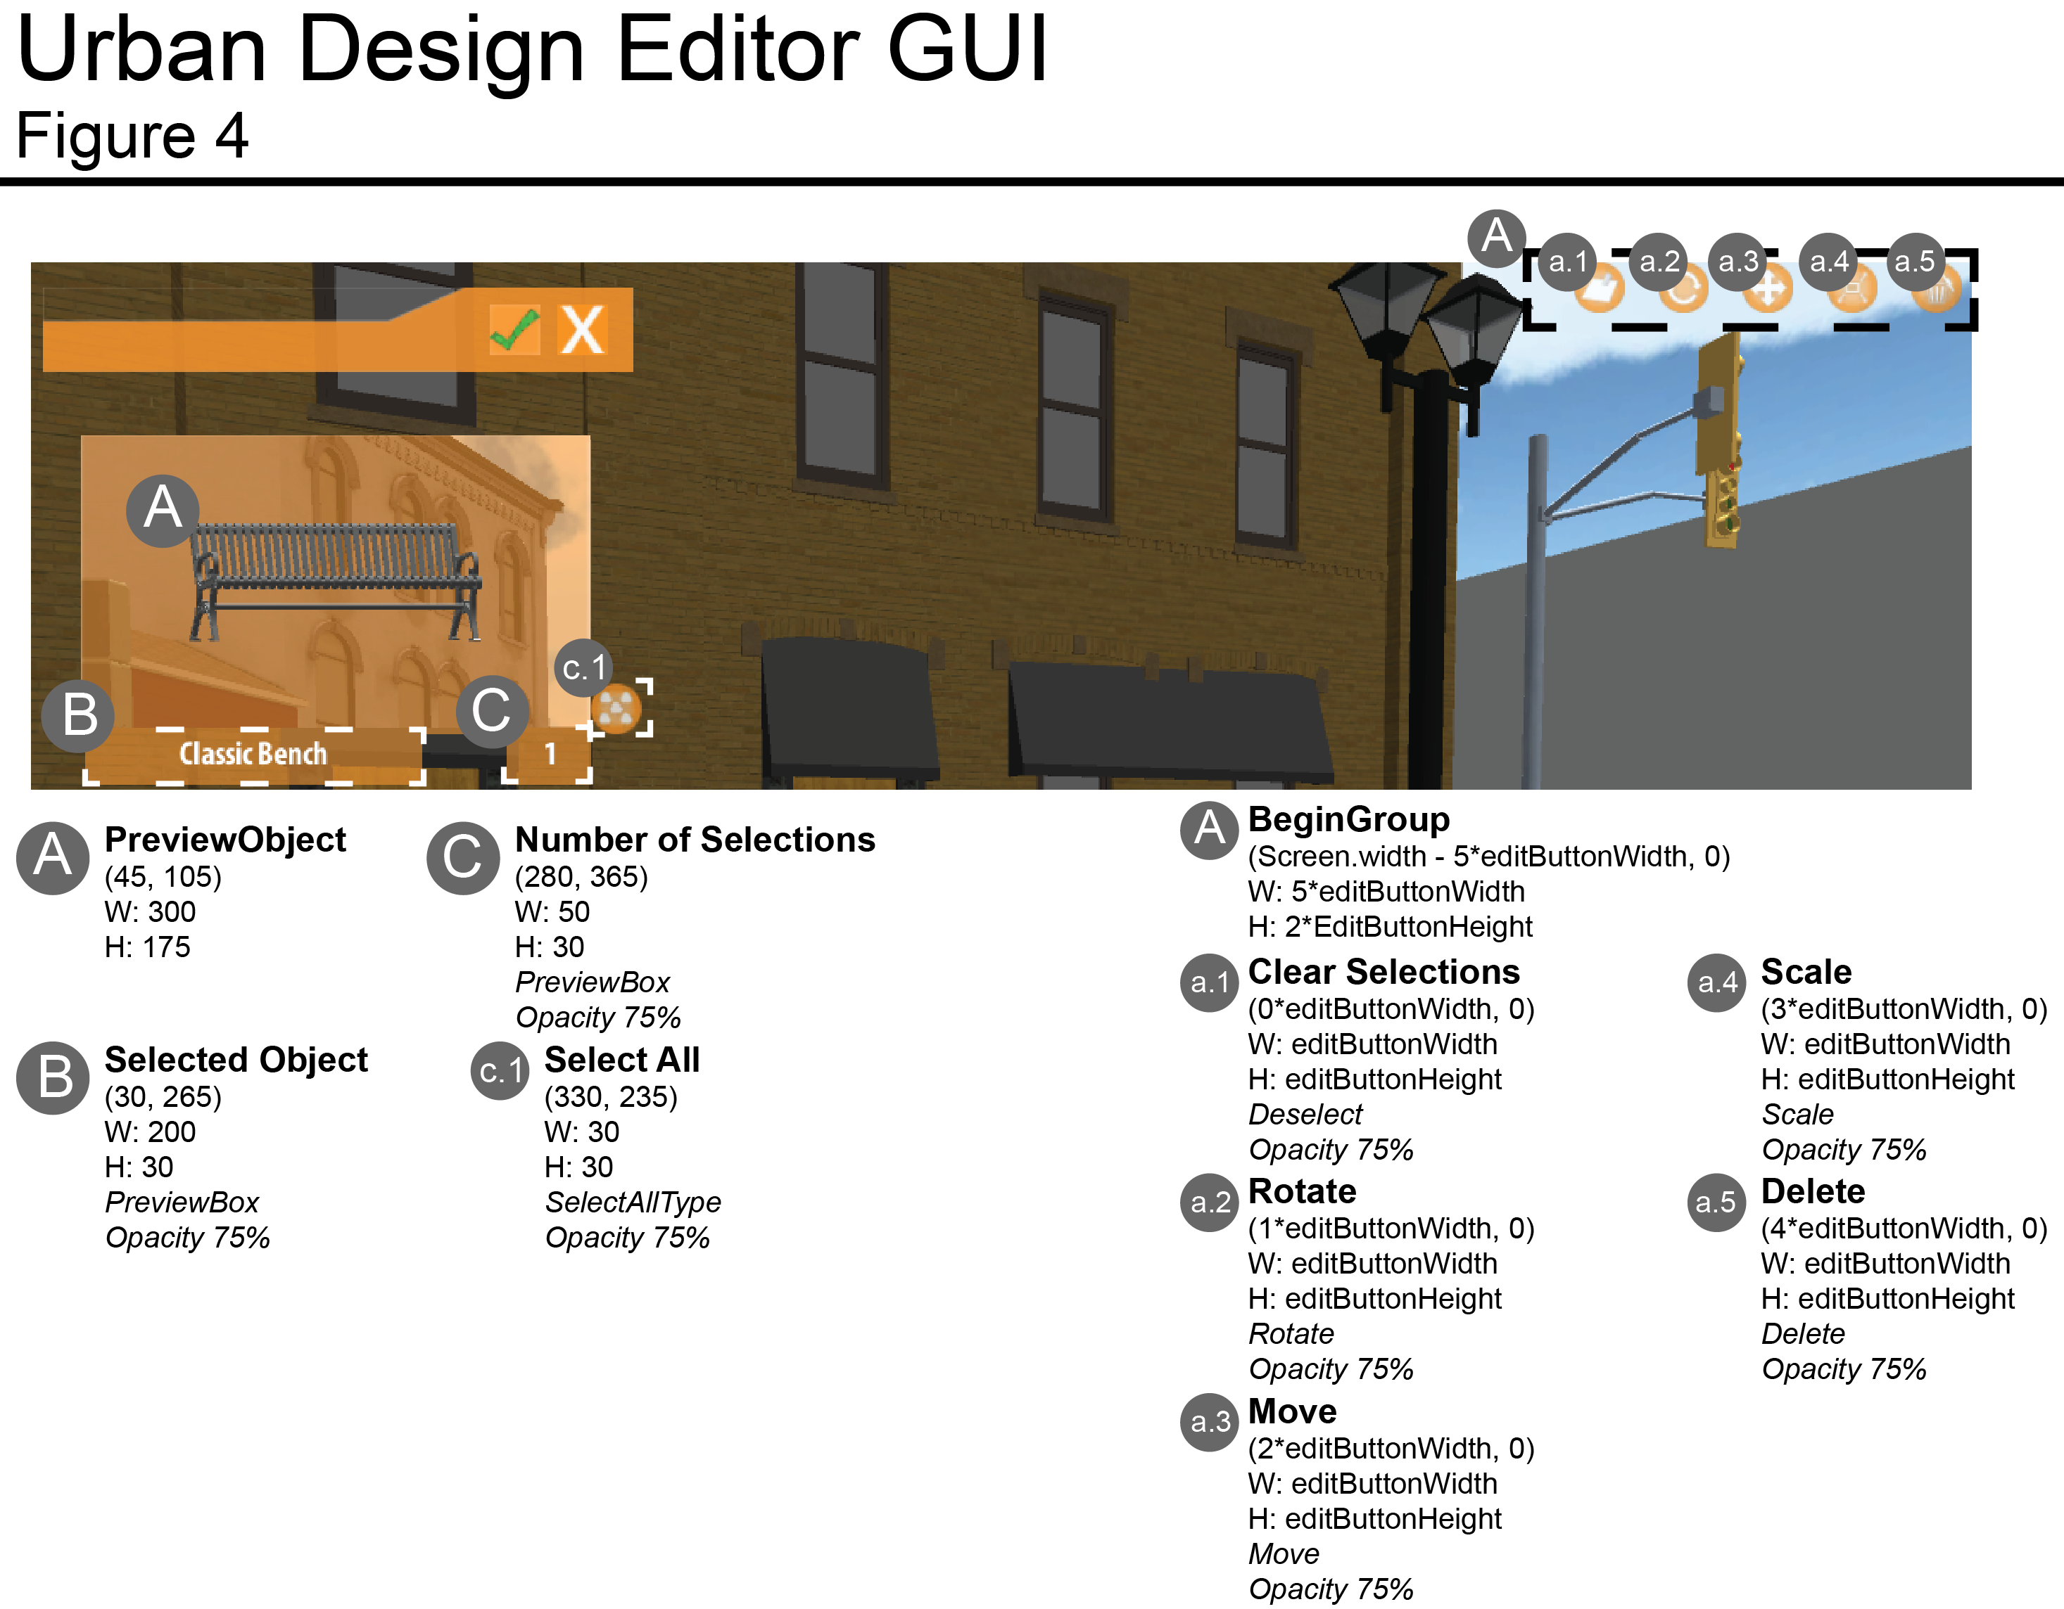

The first 2 figures provide the necessary information of the coordinate system used by the GUI Class, whereas the last 2 figures give the names and dimensions of the GUI element used. The 3 EditObjects buttons in the above figure (**a.2**, **a.3**, **a.4**) launch the 3 **UI**s from the **UIControl.js** (by the **uiAccessor** variable) script.

The **StreetFurnitureUI.js** script is called the brain of the Urban Design Editor because although it does not physically instantiate and save/load changes of the urban design objects, it tracks all the changes and handles the different modes (**Undo**, **Restore Default** and the 3 **UI**s **modes**) of the Urban Design Editor.

A good example will be the public function **RegisterUnityNameToChangeList**. The **Group.js** script of the sidewalk calls this function. This variable **changeListOfSidewalks** keeps a list of Unity Names of the sidewalks that are modified by the Urban Design Editor. Therefore, this function is called every time when object instantiates, modifies, or deletes. This list will then be processed when the “**Save Changes**” button is clicked.

Another more complex example will be the public functions **UndoSidewalk** and **RestoreSidewalkDefault**. As mentioned above and in the Hierarchy Documentation, there are different modes in the Urban Design Editor. They are simply denoted by the Booleans **undoButtonActive**, **restoreDefaultActive** and **editUIEnabled**. When the sidewalk is clicked, the **OnMouseDown** function of the **Group.js** script attached to it is called. This function will check the StreetFurnitureUI.js which mode is being used. The corresponding action is then executed.

When an object is selected while the Urban Design Editor is active, the **Edit Mode** is on. The selected object is pushed to the **objArray**. Objects in objArray can then be modified by the **UI**s. However, if the objects are to be deleted, we cannot register the changes right away because of the **Object.Destroy** issue stated in the Hierarchy Documentation. The function **RegisterDeletedObjects** takes care of it by registering the changes after a small fraction of time. The amount of time itself does not make a difference because when we use the **yield** function, the rest of the function will be executed after the specified time or the next **Update** loop.

**ObjectLibrary.js (***/Assets/IRUS Scripts/Urban Design Scripts/***)**

Next, we are going to talk about the **ObjectLibrary.js** script that assists the Urban Design Editor by sorting and providing the necessary prefabs. There are 2 classes in the ObjectLibrary script: the **Type** and the **Species**. Type is an abstraction of species. For instance, a **Street Furniture** Type contains Species like: *Classic Bench* and *Generic Bench*.

On start of the ObjectLibrary script, all the Types (In the current IRUS version, there are just 2 of them: **Street Furniture** and **Vegetation**) are loaded from the Resources Folder (*/Assets/Resources/Furniture/…*). However, this Resources folder is not the one we attached with the Build version. This Resources folder is in the Unity Project folder and will be enclosed in the Build. While the Assets folder we attached with the Build contains the Databases, Preset, Temporary and User Data folders.

After the ObjectLibrary script loads all the prefabs, they are then sorted by tags attached to them. The actual sorting algorithm occurs in the public function **loadGOToList**.

To retrieve the prefabs, the 2 public functions are used: **getSpecies**, **getSpeciesPrefabByName**.

**Group.js (***/Assets/IRUS Scripts/Urban Design Scripts/***)**

Now, we will proceed to the 3 levels under the **StreetFurnitureUI**. The **Group.js** script is attached to every sidewalk game object. It contains functions to save and load changes on the sidewalk and communicate with the StreetFurnitureUI.js script.

The 4 functions **makeObjects**, **makeSubGroup**, **checkSubGroups** and **placeObject** are used to instantiate urban design objects evenly spaced on the sidewalk. There is a **static** variable in the **Group.js** script named **NumObjects**. This variable is changed by the StreetFurnitureUI.js to control the number of urban design objects being instantiated on the sidewalk. It is used by these 4 functions.

Another public function being used to instantiate urban design object is the **PopulateUserObjects**. This function is analogous to the **LoadRoadSegment** function in the **RoadSegmentMain.js** script. It takes in a data string and breaks it up to useful pieces and then instantiates the urban design objects correspondingly. This function is being used in the sidewalk creation in the **InstantiateRoadElements.js** script and the **UndoSidewalk** and **RestoreSidewalkDefault** functions in the **StreetFurnitureUI.js** script.

There is a variable **changesMade** to indicate if the sidewalk game object has been modified. This variable is being used by the **RegisterChangesToUI** function to ensure the same Unity Name would not be inserted twice to the StreetFurnitureUI. Remember that the StreetFurnitureUI.js script keeps track with which sidewalks are being modified by their Unity Names.

The **UpdateLocalChanges** and **ReturnObjectsInfoOnSidewalk** functions are used to save the necessary information for the urban design objects to be created to the **Temporary Data**. The ReturnObjectsInfoOnSidewalk calls the children game objects recursively (through **SubGroup.js** and **GenericObject.js**) to retrieve their positions, rotations and scales.

The **OnMouseDown** function is the core part to interact with the **StreetFurnitureUI.js**. However, it does not keep track of the position of the mouse click event. To accommodate the functionality so that one urban design object can be instantiated at the mouse click position, the script use a Physics.Raycast to get the mouse click position. One drawback of this is when user clicks on the vertical side of the sidewalk, part of the object instantiated may appear in the sidewalk.

Lastly, unlike the RightOfWay Editor, the **unredoList** is stored in the Group script instead of the StreetFurnitureUI. The mechanism of the unredo list is basically the same as the RightOfWay Editor.

**SubGroup.js (***/Assets/IRUS Scripts/Urban Design Scripts/***)**

The SubGroup script is attached to the game objects holder for each of the same species on a sidewalk. There are some functions in the script that become obsolete when we integrate the EditObjectsUI with the StreetFurnitureUI. However, we have not deleted it yet because of poor documentation.

**GenericObject.js (***/Assets/IRUS Scripts/Urban Design Scripts/***)**

The actual urban design object instantiation command is in the **CreateObject** function of the **GenericObject.js** script. Note that this is a static function. At the end of the function, the instantiated object will be attached with the GenericObject script.

The GenericObject script is also responsible to “ghost” the object when it is clicked by the user. This “ghost” feature is done by the script **GhostSelectedObjects.js** script (*/Assets/IRUS Scripts/GUI Scripts/…*). The 3 public functions used by this Ghost script are: **ghost**, **showFull** and **isGhosting**. The **ghost** function creates a transparent effect on the objects while **showFull** returns the original texture. The **isGhosting** function checks if the object is being ghosted. Therefore, when the object is selected, the GhostSelectedObjects.js has to be attached to the object to produce the ghosting effect. The ghost script is destroyed when it is deselected.

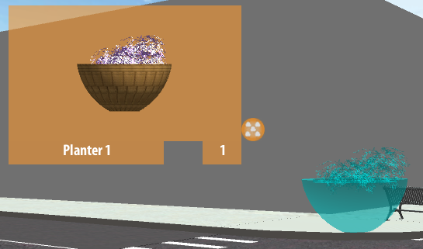

In addition, the GenericObject is the script that notifies the Group script if modification has made on the urban design object. The public function **RegisterChangesToParentGroup** calls the Group script to update the position, rotation and scale of the urban design objects below it. This function is called from various places. When the 3 **UI**s move, rotate or scale urban design objects, this function is constantly called by the StreetFurnitureUI.js (function **RegisterEditUIAction**) to update the Temporary Data.

The function **ReturnObjectDetails** returns the **localPosition**, **eulerAngles** and the **localScale** of the urban design object. Notice that the eulerAngles is used instead of the rotation variable. This is because Unity does not recommend developers to modify the **Quaternion** variable if it is not understood inside out. Therefore, instead of assigning the Quaternion directly to the object, we rotate the urban design object with the provided eulerAngles using the static function **Quaternion.Euler** (see PopulateUserObjects in **Group.js**).

To return all the information precisely, we use the **ToString** function to print out all the x, y and z coordinates of the position, rotation and scale of the urban design object.

Same as the SubGroup script, some of the functions become obsolete after we integrate with the EditObjectsUI, but we will leave it there for now.

**PreviewManager.js (***/Assets/IRUS Scripts/GUI Scripts/***)**

The Preview Cam of the Urban Design Editor uses the PreviewManager.js script.

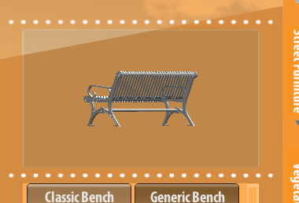

Without diving into too much details, only the **showPreviewObject**, **enablePreview** and **disablePreview** functions are being call from the outside of the script. The functions are quite self-explanatory.

**AvatarManager.js (***/Assets/IRUS Scripts/Avatar Scripts/***)**

In the Spring 2013 work term, we have introduced the avatars to IRUS. We have purchased different types of prefabs (female, male, senior, car, bus, truck and police), but only the **female**, **male** and **senior** are used (i.e. the Pedestrian).

The **CreatePedestrian** function generates a set of pedestrians. The parameter **unityName** usually denotes the road segment that the pedestrian belonged to. It is merely a method to sort all the pedestrian in the 3D world. The unityName is used as the name of the **pedestrianHolder**. Then, the **creationPosition** is simply the world position of which the pedestrian is instantiated. We will talk about the patrolLine in the **Pedestrian.js** section. The other parameters such as the **numPedestrian**, **femaleRatio**, **maleRatio** and **seniorRatio** are to control the population of the pedestrian.

Like the StreetFurnitureUI.js, the AvatarManager is the brain of the Avatar system. It generates, destroys and sets the motion of the pedestrian. One of the important function in the script is the **FindMotionName**. When we purchased the pedestrian, they come with different names for different motions. For example, walking for an OfficeLady is “**female_walk**” and for an OfficeMan is “**walk**”. This function aims to unify all the different names with a standardized motion names.

**AvatarBackend.js (***/Assets/IRUS Scripts/Avatar Scripts/***)**

The AvatarBackend contains functions to return prefabs. There are functions to return a specific prefab, a random prefab of a type and a list of prefabs of a type. These functions can be accessed from anywhere.

**Pedestrian.js (***/Assets/IRUS Scripts/Avatar Scripts/***)**

The Pedestrian.js script has a simple AI to allow the pedestrian game object to move around on the sidewalk. There are 2 variables needed to let the pedestrian walks around smoothly: **speed** and **patrolLine**. The values of them are balanced experimentally. Here we will explain how does the **patrolLine** of the pedestrian work.

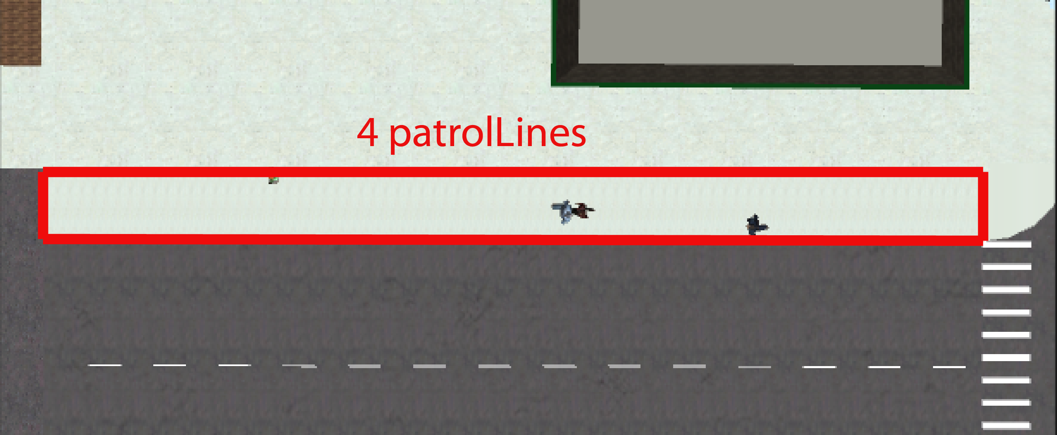

Basically, the patrolLine is an Array of **Line** Class (in the **Parcel.js** script). Each pedestrian will then randomly pick a patrolLine from the array and a point on the selected Line. The pedestrian is then move to the target point (variable **nextTargetPoint**) with the specified **speed**.

In order to have the pedestrian moves smoothly around, we have imposed a restriction on it. The distance between the nextTargetPoint and the starting point must be within 5 to 13. However, this also creates a limitation in the AI: if the distance between the nextTargetPoint and the starting point is less than 5, then the pedestrian will appear frozen at the spot.

A better AI can always be written if necessary.

**DataParse.js (***/Assets/IRUS Scripts/Backend Scripts/***)**

Now we will move to the Backend scripts of IRUS. The DataParse script contains a static class for developers to parse data.

**RoadsBackend.js (***/Assets/IRUS Scripts/Backend Scripts/***)**

The RoadsBackend script is mainly used to update the online database. It is rarely used as IRUS moves towards the standalone version.

**UserDataBackend.js (***/Assets/IRUS Scripts/Backend Scripts/***)**

The **UserDataBackend.js** script is created to deal with all the database and text files under the Resources folder attached with the Build version. It uses the **System.IO** class; therefore, it is only functional in a standalone version (Mac or Windows).

Most of the public functions in the UserDataBackend are used outside the script. The **CreateAllRoads.js** script uses the **RetrieveRoadsInfo** and **RetrieveIntersectionsInfo** functions to extract the 2 (.csv) databases. A large portion of the public functions is used by the RightOfWay Editor and the Urban Design Editor to dynamically read and write text files.

In addition, the script is responsible for clearing the temporary data path on start. There is also a **GetLastLoginTime** function that registers the login time.